HMI
  - <Industrial Control>

Submitted by:
<Marco Túlio F. Hudson WS>

MODULE B - PROGRAMMING

HMI – SCREEN “MANUAL”
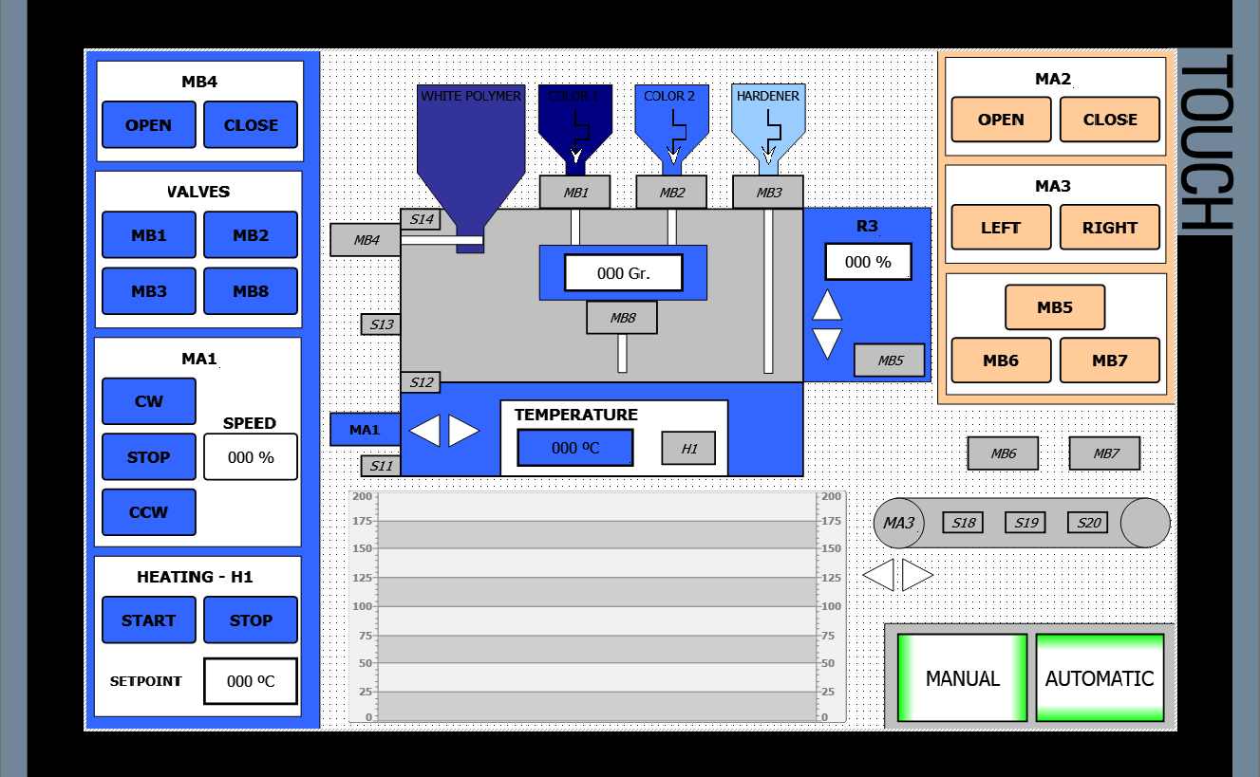

HMI – SCREEN “AUTOMATIC”
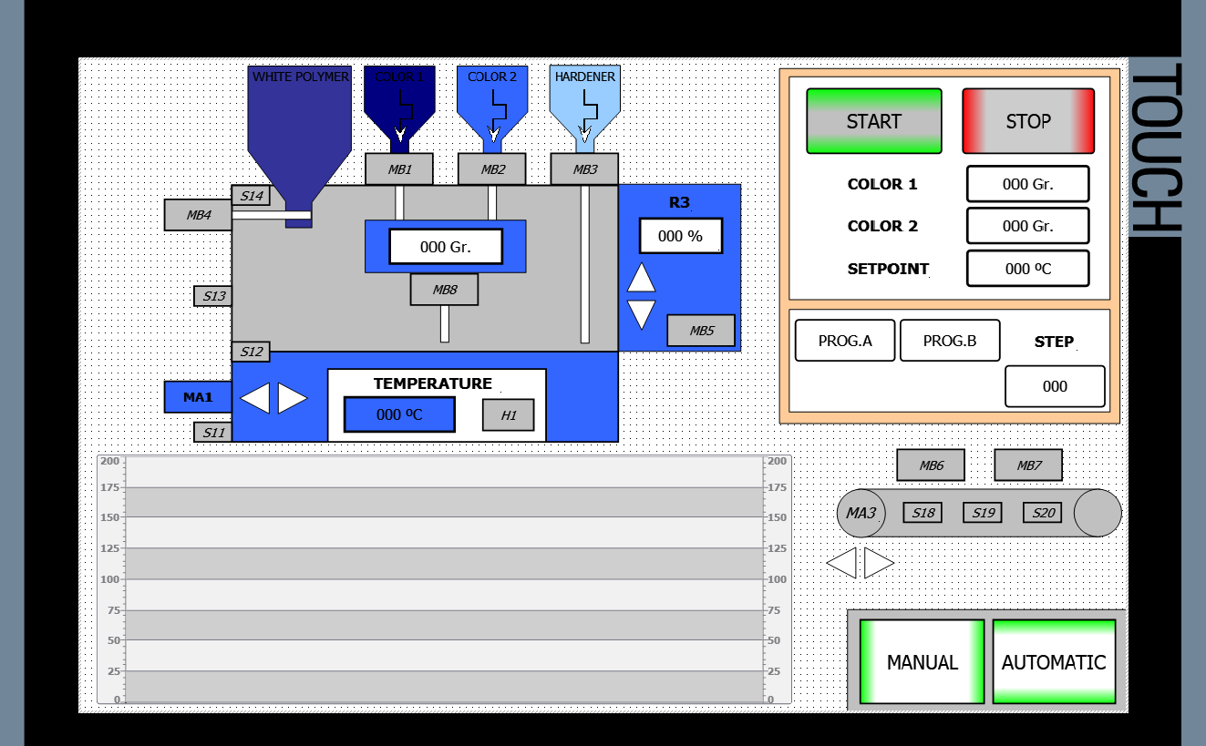

VSD
The changes in speed and the 0-speed will be reached in 3 seconds.
The ramps must be programmed in the variable speed device (VSD).

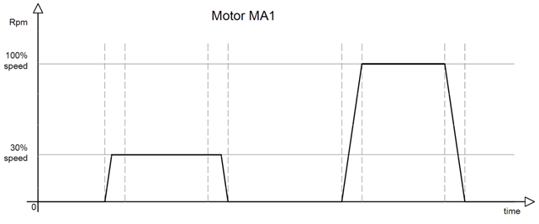

PLC Inputs / Outputs
SYMBOL | TYPE | COMMENT
K3:DI-BIT_0 | BOOL | PLC - Input (K3)
S11 | BOOL | PLC - Input (K3)
S12 | BOOL | PLC - Input (K3)
S13 | BOOL | PLC - Input (K3)
S14 | BOOL | PLC - Input (K3)
MA2_Open (MA2_Right - Q5) | BOOL | PLC - Output (K3)
MA2_Close (MA2_Left - Q6) | BOOL | PLC - Output (K3)
Q8 (Contactor for T2) | BOOL | PLC - Output (K3)
Q9 (Contactor for VSD) | BOOL | PLC - Output (K3)
P10 | BOOL | PLC - Output (K3)
P11 | BOOL | PLC - Output (K3)
P12 | BOOL | PLC - Output (K3)
P13 | BOOL | PLC - Output (K3)
K2-AO_CH0 | INT | PLC - Output (K2)
K2-AO_CH1 | INT | PLC - Output (K2)
K2-AI_CH0 | INT | PLC - Input (K2)
S5 | BOOL | Sirius ACT Module - Input (A5)
S4 | BOOL | Sirius ACT Module - Input (A5)
S3_L | BOOL | Sirius ACT Module - Input (A5)
S3_R | BOOL | Sirius ACT Module - Input (A5)
P1 | BOOL | Sirius ACT Module - Output (A5)
P2 | BOOL | Sirius ACT Module - Output (A5)
S15 | BOOL | ET200SP - Input (K6)
S16 | BOOL | ET200SP - Input (K6)
S17 | BOOL | ET200SP - Input (K6)
S10 | BOOL | ET200SP - Input (K6)
S21 | BOOL | ET200SP - Input (K6)
K8:AI:U_CH0 (R2) | INT | ET200SP - Input (K6)
K8:AI:U_CH1 (R3) | INT | ET200SP - Input (K6)
K9:AQ-U_CH0 | INT | ET200SP - Output (K9)
MA3_Right (Q10) | BOOL | ET200SP - Output (K7)
MA3_Left (Q11) | BOOL | ET200SP - Output (K7)
MB1 | BOOL | ET200SP - Output (K7)
MB2 | BOOL | ET200SP - Output (K7)
MB3 | BOOL | ET200SP - Output (K7)
MB4 | BOOL | ET200SP - Output (K7)
P16 | BOOL | ET200SP - Output (K7)
S6 | BOOL | IO-Link - Input (K10 + Pos.18)
S7 | BOOL | IO-Link - Input (K10 + Pos.18)
S8 | BOOL | IO-Link - Input (K10 + Pos.18)
S9 | BOOL | IO-Link - Input (K10 + Pos.18)
P14 | BOOL | IO-Link - Output (K10 + Pos.18)
MB5 | BOOL | IO-Link - Output (K10 + Pos.18)
P15 | BOOL | IO-Link - Output (K10 + Pos.18)
S18 | BOOL | ET200Eco - Input (A6)
S19 | BOOL | ET200Eco - Input (A6)
S20 | BOOL | ET200Eco - Input (A6)
MB6 | BOOL | ET200Eco - Output (A6)
MB7 | BOOL | ET200Eco - Output (A6)
MA1_Speed | REAL | VSD (by Profinet)
MA1_CW | BOOL | VSD (by Profinet)
MA1_CCW | BOOL | VSD (by Profinet)

Control HMI / PLC Variables
SYMBOL | TYPE | COMMENT
Emergency | BOOL | PLC-Variable
Reset | BOOL | PLC-Variable
Mode_Auto | BOOL | PLC-Variable
Mode_Manual | BOOL | PLC-Variable
MB4_Open | BOOL | PLC-Variable
MB4_Close | BOOL | PLC-Variable
MB1_Button | BOOL | PLC-Variable
MB2_Button | BOOL | PLC-Variable
MB3_Button | BOOL | PLC-Variable
MB8_Button | BOOL | PLC-Variable
MB8 | BOOL | PLC-Variable
MA1_CW_Button | BOOL | PLC-Variable
MA1_Stop_Button | BOOL | PLC-Variable
MA1_CCW_Button | BOOL | PLC-Variable
Start_Heating | BOOL | PLC-Variable
Stop_Heating | BOOL | PLC-Variable
Heating_Setpoint | REAL | PLC-Variable
Temperature | REAL | PLC-Variable
Heater_PWM | REAL | PLC-Variable
Heater_ON | BOOL | PLC-Variable
Hysteresis | REAL | PLC-Variable
Point_On | REAL | PLC-Variable
Point_Middle | REAL | PLC-Variable
MA2_Close_Button | BOOL | PLC-Variable
MA2_Open_Button | BOOL | PLC-Variable
MA3_Left_Button | BOOL | PLC-Variable
MA3_Right_Button | BOOL | PLC-Variable
Drain_tk4 | BOOL | PLC-Variable
MB5_Button | BOOL | PLC-Variable
MB6_Button | BOOL | PLC-Variable
MB7_Button | BOOL | PLC-Variable
Balance | REAL | PLC-Variable
Thickness | REAL | PLC-Variable
Button_A | BOOL | PLC-Variable
Button_B | BOOL | PLC-Variable
Program_A | BOOL | PLC-Variable
Program_B | BOOL | PLC-Variable
Step | REAL | PLC-Variable
Start | BOOL | PLC-Variable
Stop | BOOL | PLC-Variable
Color1_Gr | REAL | PLC-Variable
Color2_Gr | REAL | PLC-Variable
Pause | BOOL | PLC-Variable
Cycle_active | BOOL | PLC-Variable
MA1_Speed_Injection | REAL | PLC-Variable
Time | Time | PLC-Variable

Details: Screen Manual
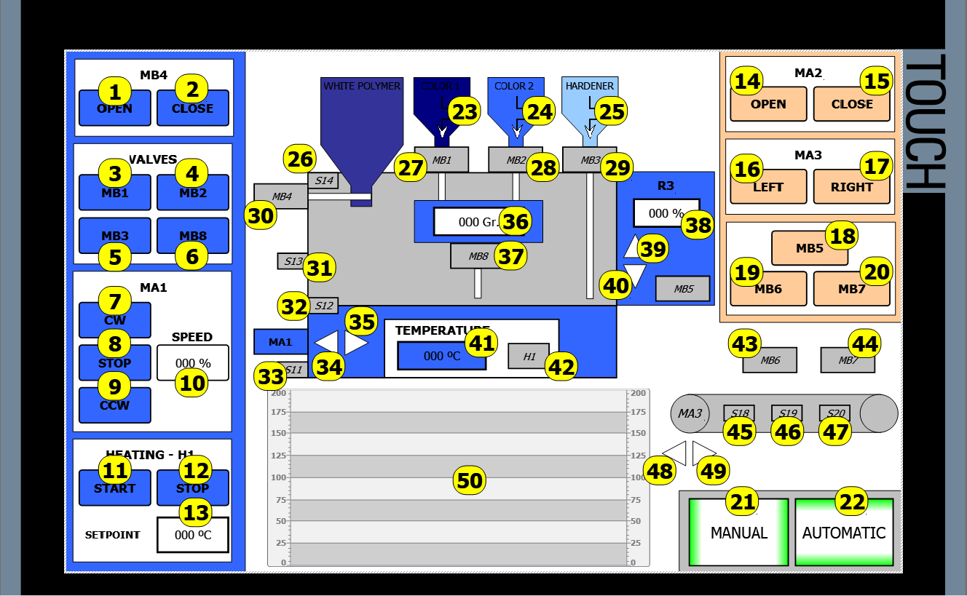
POSITION | VARIABLE | ACTION | COMMENT
1 | MB4_Open | Button Event | Set bit while key is pressed
2 | MB4_Close | Button Event | Set bit while key is pressed
3 | MB1_Button | Button Event | Set bit while key is pressed
4 | MB2_Button | Button Event | Set bit while key is pressed
5 | MB3_Button | Button Event | Set bit while key is pressed
6 | MB8_Button | Button Event | Set bit while key is pressed
7 | MA1_CW_Button | Button Event | Set bit while key is pressed
8 | MA1_Stop_Button | Button Event | Set bit while key is pressed
9 | MA1_CCW_Button | Button Event | Set bit while key is pressed
10 | MA1_Speed | Output field | Range: 0 to 110%
11 | Start_Heating | Button Event | Set bit while key is pressed
12 | Stop_Heating | Button Event | Set bit while key is pressed
13 | Heating_Setpoint | Input/Output field | Range: 50 to 200 ºC
14 | MA2_Open_Button | Button Event | Set bit while key is pressed
15 | MA2_Close_Button | Button Event | Set bit while key is pressed
16 | MA3_Left_Button | Button Event | Set bit while key is pressed
17 | MA3_Right_Button | Button Event | Set bit while key is pressed
18 | MB5_Button | Button Event | Set bit while key is pressed
19 | MB6_Button | Button Event | Set bit while key is pressed
20 | MB7_Button | Button Event | Set bit while key is pressed
21 | --- | Button Event | Activate Screen "Manual"
 | Mode_Manual | Background Control Color | State "0" = WHITE
 |  |  | State "1" = GREEN
22 | --- | Button Event | Activate Screen "Automatic"
 | Mode_Auto | Background Control Color | State "0" = WHITE
 |  |  | State "1" = GREEN
23 | S15 | Visibility | State "0" = Visible
 |  |  | State "1" = Invisible
24 | S16 | Visibility | State "0" = Visible
 |  |  | State "1" = Invisible
25 | S17 | Visibility | State "0" = Visible
 |  |  | State "1" = Invisible
26 | S14 | Background Control Color | State "0" = GRAY
 |  |  | State "1" = GREEN
27 | MB1 | Background Control Color | State "0" = GRAY
 |  |  | State "1" = GREEN
28 | MB2 | Background Control Color | State "0" = GRAY
 |  |  | State "1" = GREEN
29 | MB3 | Background Control Color | State "0" = GRAY
 |  |  | State "1" = GREEN
30 | MB4 | Background Control Color | State "0" = GRAY
 |  |  | State "1" = GREEN
31 | S13 | Background Control Color | State "0" = GRAY
 |  |  | State "1" = GREEN
32 | S12 | Background Control Color | State "0" = GRAY
 |  |  | State "1" = GREEN
33 | S11 | Background Control Color | State "0" = GRAY
 |  |  | State "1" = GREEN
34 | MA1_CCW | Background Control Color | State "0" = WHITE
 |  |  | State "1" = GREEN
35 | MA1_CW | Background Control Color | State "0" = WHITE
 |  |  | State "1" = GREEN
36 | Balance | Output field | Range: 0 to 500
37 | MB8 | Background Control Color | State "0" = GRAY
 |  |  | State "1" = GREEN
38 | Thickness | Output field | Range: 0 to 100
39 | MA2_Open | Background Control Color | State "0" = WHITE
 |  |  | State "1" = GREEN
40 | MA2_Close | Background Control Color | State "0" = WHITE
 |  |  | State "1" = GREEN
41 | Temperature | Output field | Range: 0 to 200
42 | Heater_ON | Background Control Color | State "0" = GRAY
 |  |  | State "1" = GREEN
43 | MB6 | Background Control Color | State "0" = GRAY
 |  |  | State "1" = GREEN
44 | MB7 | Background Control Color | State "0" = GRAY
 |  |  | State "1" = GREEN
45 | S18 | Background Control Color | State "0" = GRAY
 |  |  | State "1" = GREEN
46 | S19 | Background Control Color | State "0" = GRAY
 |  |  | State "1" = GREEN
47 | S20 | Background Control Color | State "0" = GRAY
 |  |  | State "1" = GREEN
48 | MA3_Left | Background Control Color | State "0" = WHITE
 |  |  | State "1" = GREEN
49 | MA3_Right | Background Control Color | State "0" = WHITE
 |  |  | State "1" = GREEN
POSITION | VARIABLE | ACTION | COMMENT
50 | Heating_Setpoint | Trend | Style GREEN; Trend values:999
 | Point_ON | Trend | Style BLACK; Trend values:999
 | Point_Middle | Trend | Style BLUE; Trend values:999
 | Temperature | Trend | Style RED; Trend values:999
 | -- | Properties - Time axis | Range: 30s
 | -- | Properties - Temperature axis | Range: 200ºC

Details: Screen Automatic
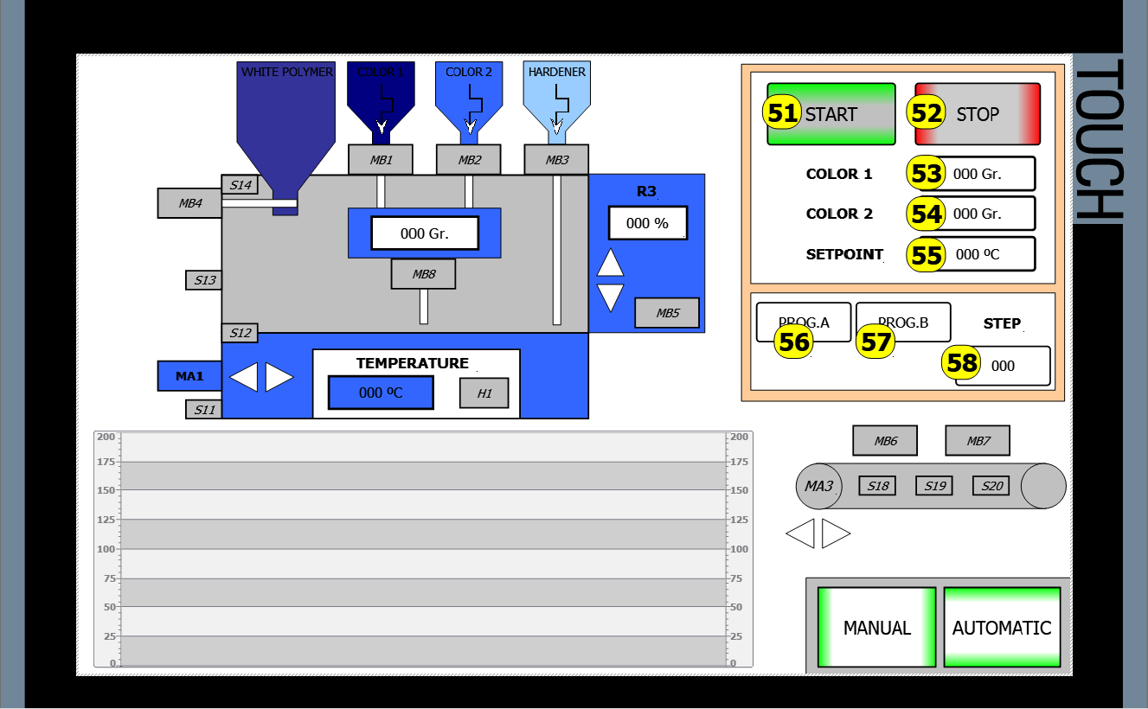

POSITION | VARIABLE | ACTION | COMMENT
51 | Start | Button Event | Set bit while key is pressed
52 | Stop | Button Event | Set bit while key is pressed
53 | Color1_Gr | Input/Output field | Range: 0 to 150
54 | Color2_Gr | Input/Output field | Range: 0 to 150
55 | Heating_Setpoint | Output field | Range: 0 to 200
56 | Button_A | Button Event | Set bit while key is pressed
 | Program_A | Background Control Color | State "0" = WHITE
 |  |  | State "1" = GREEN
57 | Button_B | Button Event | Set bit while key is pressed
 | Program_B | Background Control Color | State "0" = WHITE
 |  |  | State "1" = GREEN
36 | Step | Output field | Range: 0 to 99

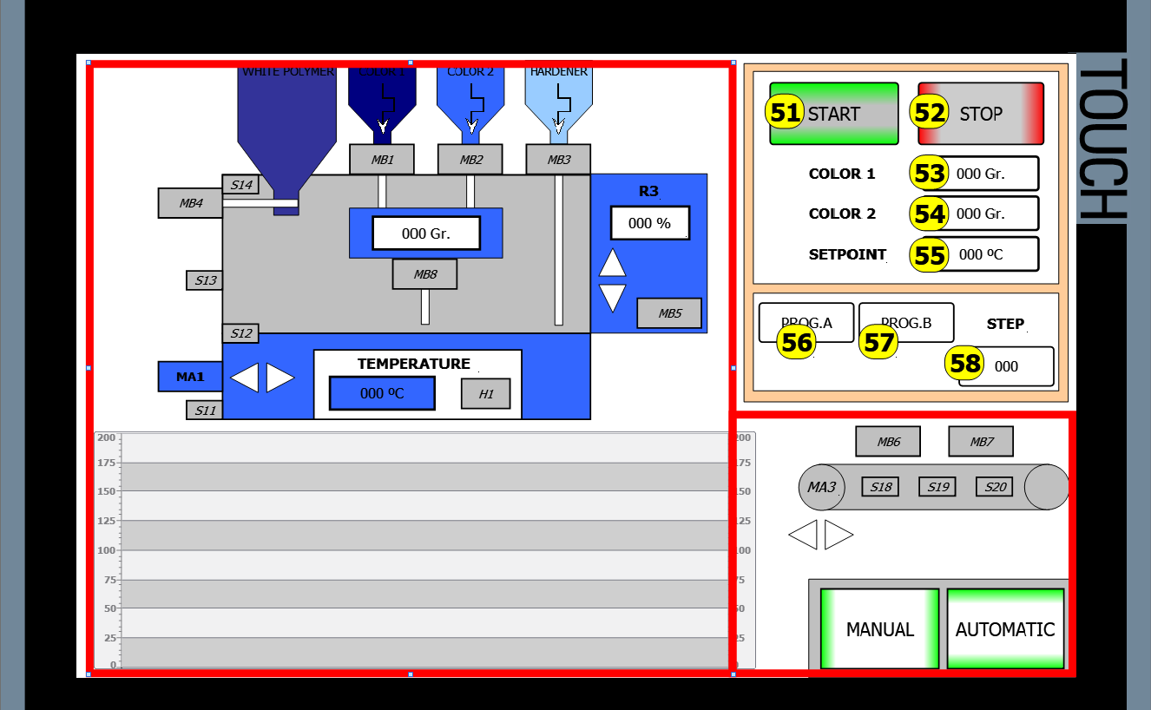

The functions from the drawing of the Screen Automatic are the same from the drawing of the Screen Manual with the exception of the things that are outside the red square in the image.

Details: emergency pop-up
The next function happens in both screens.
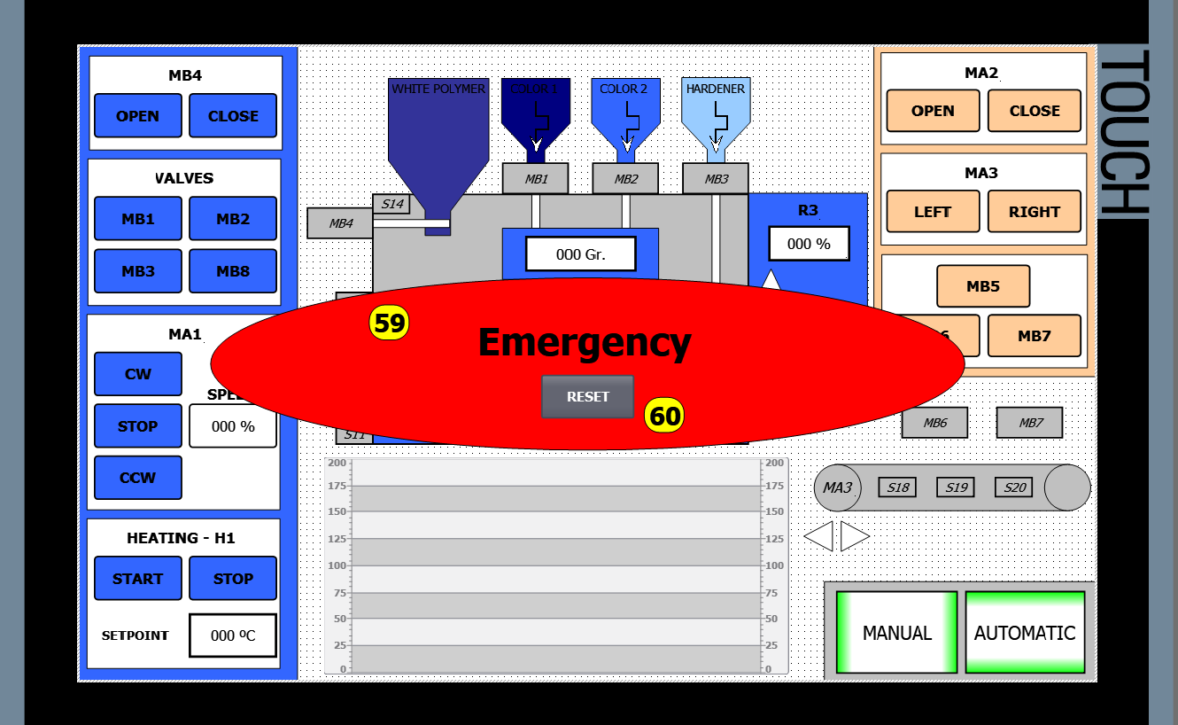
POSITION | VARIABLE | ACTION | COMMENT
59 | Emergency | Visibility | State "0" = Visible
 |  |  | State "1" = Invisible
60 | Reset | Button Event | Set bit while key is pressed

